RFP# FY1920-CaseComplexity-001
Response to Written Inquires
Posted on 3/4/20

Submitted by Adventurous Analytics, LLC. on 3/02/20
Question 1 | Section A Part 3 near top of Page 5 describes, "Data tool should be designed in a way that can feed, process and output results in an automated fashion so that it can be scheduled and easily integrated with systems already in use by Embrace Families CBC."  - How will data be available for development?  - During the RC project data was provided in delimited text files. Will the same process be used for the CCDT project or will we have access to a development and/or test environment database?  - How will data be available to the tool in the production environment?  - For example, will the tool need to expect refreshed text files on a schedule, or will the tool have access to source databases for inputs in the production environment such as an ODBC connection?  - Do you intend the end solution to have a GUI Graphical User Interface (GUI)?  - What existing system(s) does the tool need to integrate with? If there are specific requirements for the output format or integration with another software's API, please provide details.  - From our experience on the RC project we believe the intent here may be output in JSON format that will be consumed by internal Embrace Families team members. Is the intent similar in the CCDT project?  - What database does Embrace Families utilize with manufacturer & version (ex. MS SQL Enterprise 2017)?  f. What is the target operating system and version (ex. Windows Server 2016 Standard)?
Answer 1 | a. Data will be provided via secure FTP in pipe delimited format. Several files will be included. b. The tool will need to be able to be scheduled to run (or run manually when needed). When the tool executes, it will need to look for input files in a specified by the tool. After the predictive model executes, it needs to create a pipe delimited export file that can be imported into a production system. c. It is not required (especially for the end consumer), however a GUI for administrative purpose could be helpful (specifying import file location, export file location, scheduling options, etc.). d. JSON would be acceptable. Exporting to pipe delimited text file is preferred. e. MS SQL 2016. f. Window Server 2016 Datacenter.
Question 2 | Concerning case load optimization:  - Is it valid to assume that once a case is assigned to a case manager, it is undesirable to re-assign the case to a different case manager?  - Is there a typical cycle for case assignment? For example, are cases assigned immediately as they come in, once per day/week/bi-monthly/monthly?  - Is the current assignment cycle a constraint or is it possible to change the assignment cycle?
Answer 2 | a. Yes.  b. Cases are assigned to case managers at case transfer staffings. This is the point wherein a child protective investigator is replaced with a case manager as the primary person on the case.  c. Case transfer staffings are on pre-established days during the week. We may be able to influence this.
Question 3 | Section C Question 14, asks for on-premises hardware and software requirements.  - Do you want us to provide specs for new hardware & software or do intend to implement on existing equipment?  - If existing equipment, can you provide the specs of the current equipment you want to use?  - If new equipment, should the proposal include purchase, installation and setup costs or only make a recommendation on the specifications for your team to purchase and install?  - In either case we can provide estimates of minimum recommended equipment specs concerning RAM, storage and CPU capabilities. Is there anything beyond this you are looking for in the hardware / software recommendations?
Answer 3 | a. Preferably on existing hardware  a.i. 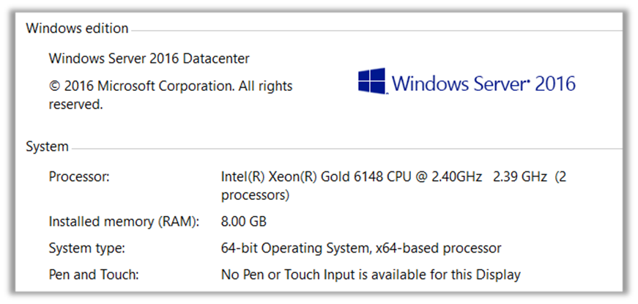  a.ii. If new equipment is required, purchase, installation and setup can be included. Installation and setup of the tool should be included regardless of the equipment used.  a.iii. Open source data platforms such as Python and R are preferred. Windows compatibility is preferred.
Question 4 | Are all types of insurance listed in Section E: C. Required Appendices and Additional Information, 7. Proof of Agency insurance required to be considered for the project?  - General Liability  - Property Casualty  - Directors and Officers  - Professional Liability  - Sexual Abuse and Molestation (if applicable)  - Umbrella  - Worker's Compensation
Answer 4 | Insurance limits can be discussed as this contract would not have direct contact with clients. At a minimum, General and Professional Liability is required.
Question 5 | Is the Independent Audit and Management Letter a requirement to be considered?
Answer 5 | If the agency does not expend $750,000 or more in Federal and/or State awards during its fiscal year, the agency is exempt from the requirement to have a federal single, state single or program-specific audit conducted in accordance with the provisions of 2 CFR §§ 200.500- 200.521, and Section 215.97, Florida Statutes; applicable rules of the Department of Financial Services; and Chapters 10.550 (local governmental entities) or 10.650 (nonprofit and for-profit organizations), Rules of the Auditor General.
Question 6 | Is there flexibility in the project start date of April 20, 2020 there seem to be overlapping statements of start date expectation?  - Section A: 5. Term of Agreement (page 5) - indicates the project will begin on or before April 20,2020  - Section B: Schedule of Events and Deadlines (page 7) - indicates anticipated effective date between 04.20.20 - 09.30.20.
Answer 6 | While there is some flexibility, the initial “tool” will need to be developed in time for us to pilot and fully launch it before September 30, 2020.

